|  |  |
| --- | --- |
| Date : | 13th Nov 2022 |
| Project Topic : | IoT Based Safety Gadget for Child Safety Monitoring & Notification |
| Team ID : | PNT2022TMID40778 |

**Creating and Connecting IBM cloud for Project and Python CodeCreating IBM Cloud Service and creating the device:**

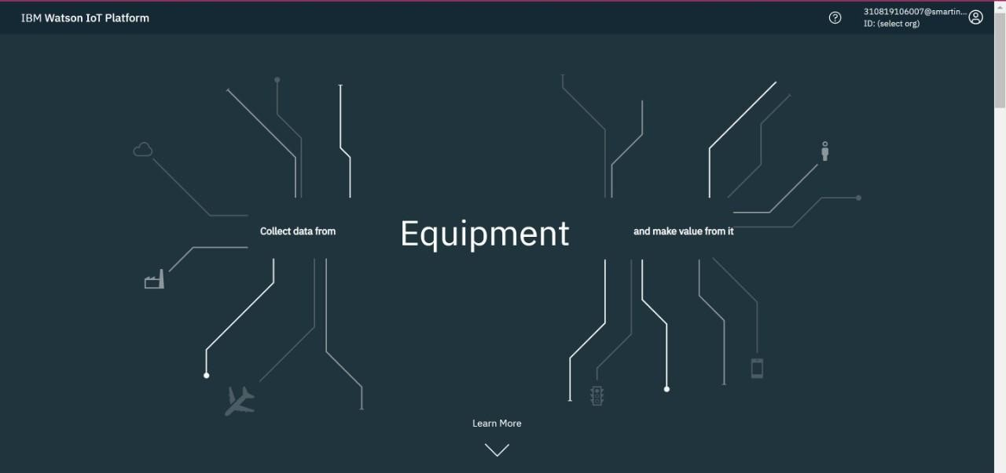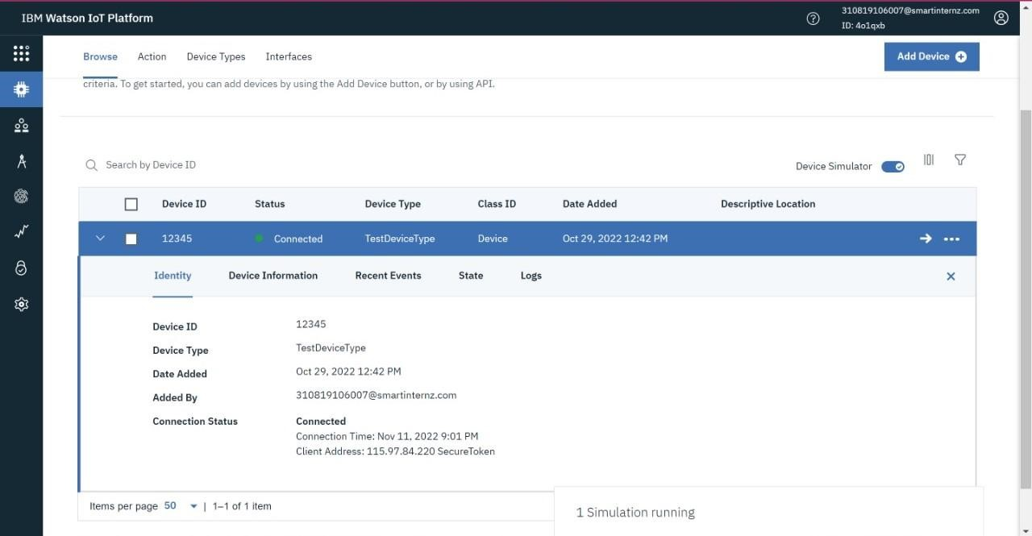

**Creating Python Code:**

import json import wiotp.sdk.device import time import random myConfig = {

"identity":{

"orgId": "4o1qxb",

"typeId": "TestDeviceType",

"deviceId": "12345"

},

"auth": {

"token":"pnhXvzN-sWMKv&hxyi"

} } client = wiotp.sdk.device.DeviceClient(config=myConfig, logHandlers=None) client.connect()

while True:

name= "Smartbridge" #in area location

latitude= 17.4225176 longitude= 78.5458842 #out area location

#latitude= 17.4219272

#longitude= 78.5488783 myData={'name': name,'lat':latitude, 'lon' :longitude} client.publishEvent(eventId="status", msgFormat="json", data=myData,

qos=0, onPublish=None) print("Data Published to IBM IoT platfrom: ", myData) time.sleep(5) client.disconnect()

**Connecting IBM Watson and python Code:**

**In-Area Location:**

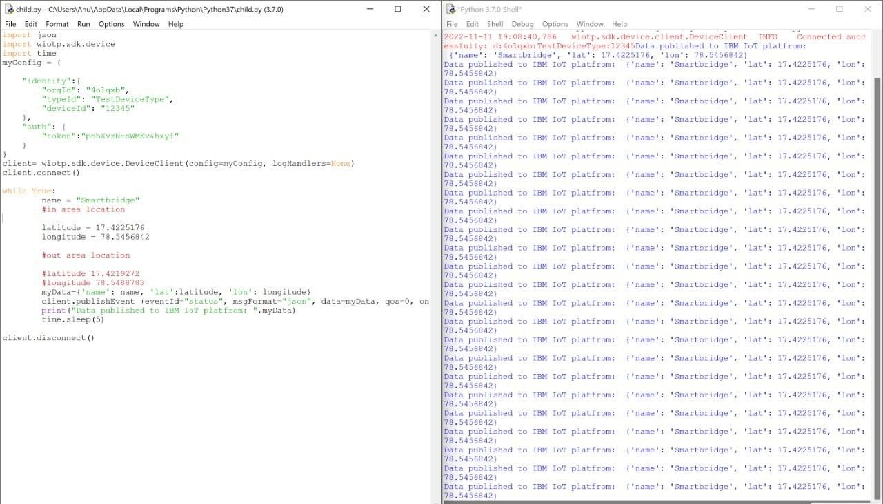

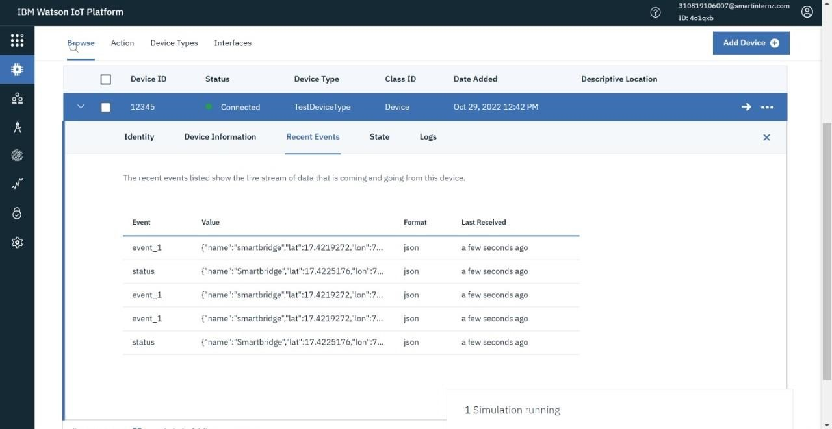

**Out-Area Location:**

